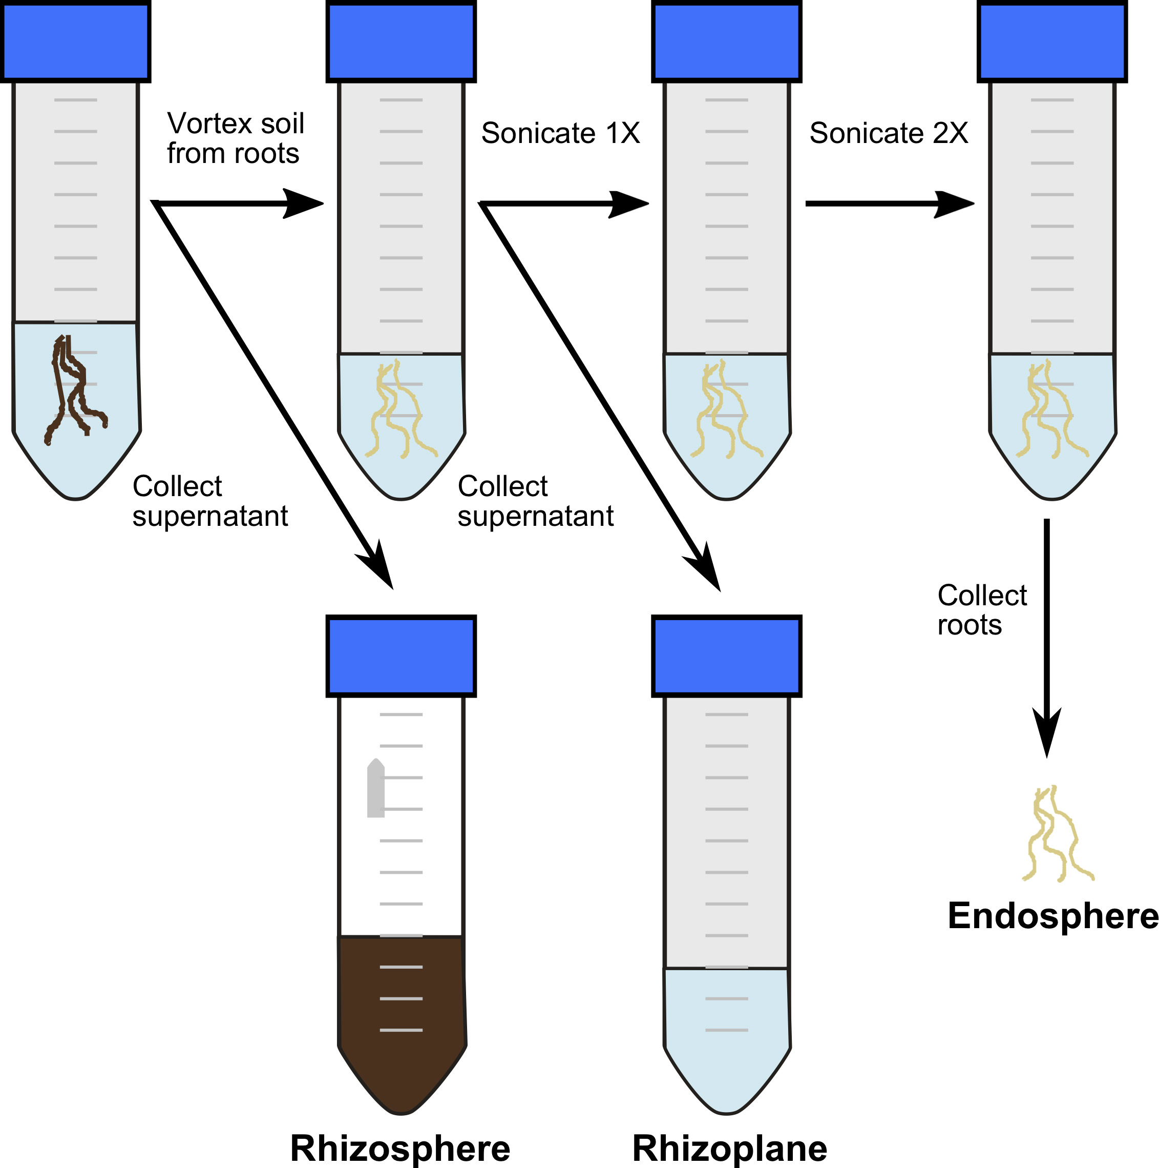
Figure S1. Compartment separation of root-associated microbiota

